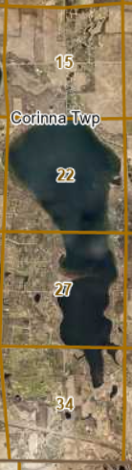

This summer, Chase Philippi, Principal Appraiser for the Wright County Assessor’s Office will be conducting the State required 5 year quintile review, re-measuring and taking photos of all improvements and property located with Section 15, 22, 27, 34 and all platted property within, and on Cedar Lake.